**Creating and configurating a Virtual Machine:**

* 1: Download the Virtualbox where we will run our virtual machine. We also need to donwload the ISO archive where our virtual machine is. (This has been given by the teacher)

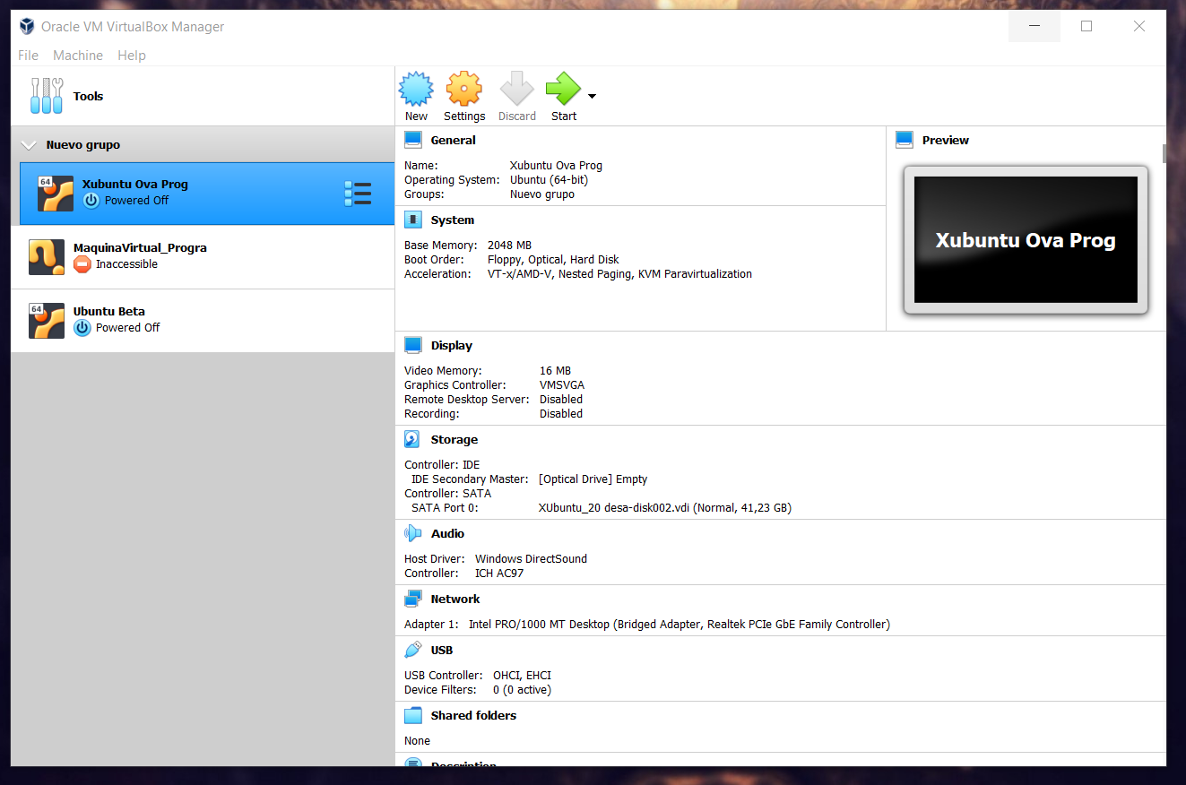

* Once the machine has been instaled, we should press “New” to set up the new machine with the operative system that we choose. ( In this case is Xubuntu)

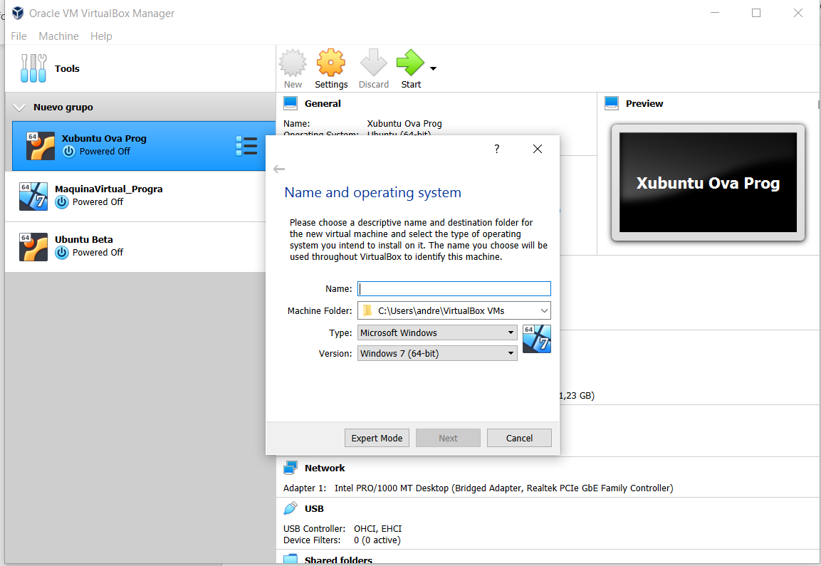

Here we select the place where we have saved our ISO archive. We also need ton ame our virtual Machine.

* Then we hace to select the amount of memory that our Virtual Machine would share with our principal system.

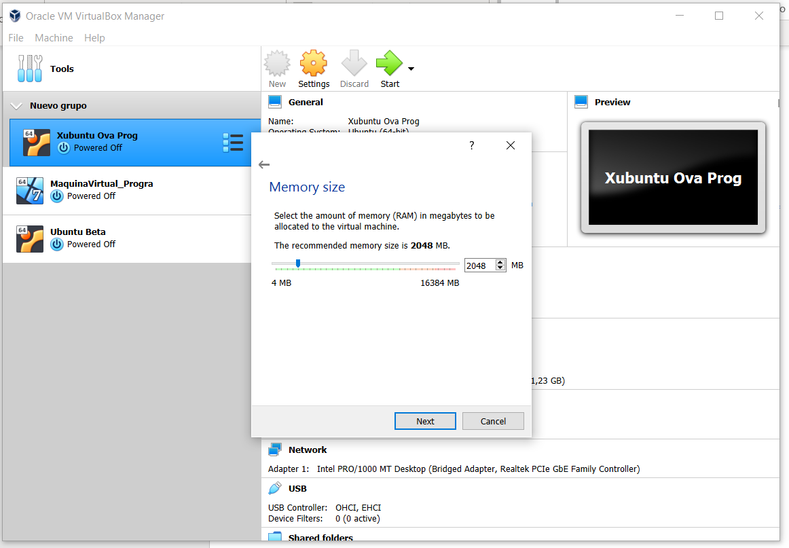

* Then we have to select de space that we are giving to the Virtual Machine.

